

**SOCIETY FOR EMPLOYMENT PROMOTION AND TRAINING IN TWIN CITIES**

**(Department of Youth Services, Government of Telangana)**

**PROJECT WORK**

**GEMS CRAFT**



**SYED ANWAR**

**Technical Training Institute**

**Purani Haveli, Hyderabad**

**Telangana – India 2023**

**GEMS CRAFT PROJECT**

**INDEX**

|  |  |  |
| --- | --- | --- |
| **S. NO.** | **LIST OF GEMS STONE** | **PAGE NO.** |
| **1** | **Jasper** | **3** |
| **2** | **Stars Stone** | **5** |
| **3** | **Tiger’s Eye** | **7** |
| **4** | **Aqua Marine** | **9** |
| **5** | **Lapis Lazuli** | **11** |
| **6** | **Amethyst** | **13** |
| **7** | **Turquoise** | **15** |
| **8** | **Serpentine** | **17** |
| **9** | **Rose Quartz** | **19** |
| **10** | **Garnet** | **21** |
| **11** | **Labradorite** | **23** |
| **12** | **Malachite** | **25** |
| **13** | **Moon Stone** | **27** |
| **14** | **Opal** | **29** |
| **15** | **Avancharine** | **31** |

**JASPER**

**INTRODUCTION: - Jasper is a beautiful and diverse group of microcrystalline quartz gemstones that come in a wide range of colours and patterns. It has been used for centuries in jewellery and other decorative items.**

**Jasper is primarily composed of silicon dioxide (SiO2), the same mineral that makes up quartz. It may also contain various impurities, which give it its distinct colours and patterns, appear in intricate patterns and bands. Different impurities or mineral inclusions in the jasper can create its variety of colours. For example, red jasper gets its colour from iron oxides, while green jasper may contain chlorite or amphibole minerals.**

**IDENTIFICATION PROPERTIES:-**

|  |  |
| --- | --- |
| **Chemical Formula:** | **Silicon dioxide (SiO2),** |
| **Crystal Structure:** | **Hexagonal crystal system** |
| **Colour:** | **Red, brown, yellow, green, and blue.** |
| **Lustre:** | **Vitreous** |
| **Transparency:** | **opaque** |
| **Fracture** | **Conchoidal (shell-like) fracture** |
| **Cleavage:** | **No cleavage** |
| **Hardness:** | **6.5 to 7** |
| **Density:** | **2.58 and 2.91 g/cm³.** |
| **Form** | **Cryptocrystalline** |
| **Refractive Index:** | **1.54 to 1.55** |
| **Double Refraction:** | **None** |
| **Fluorescence:** | **None** |

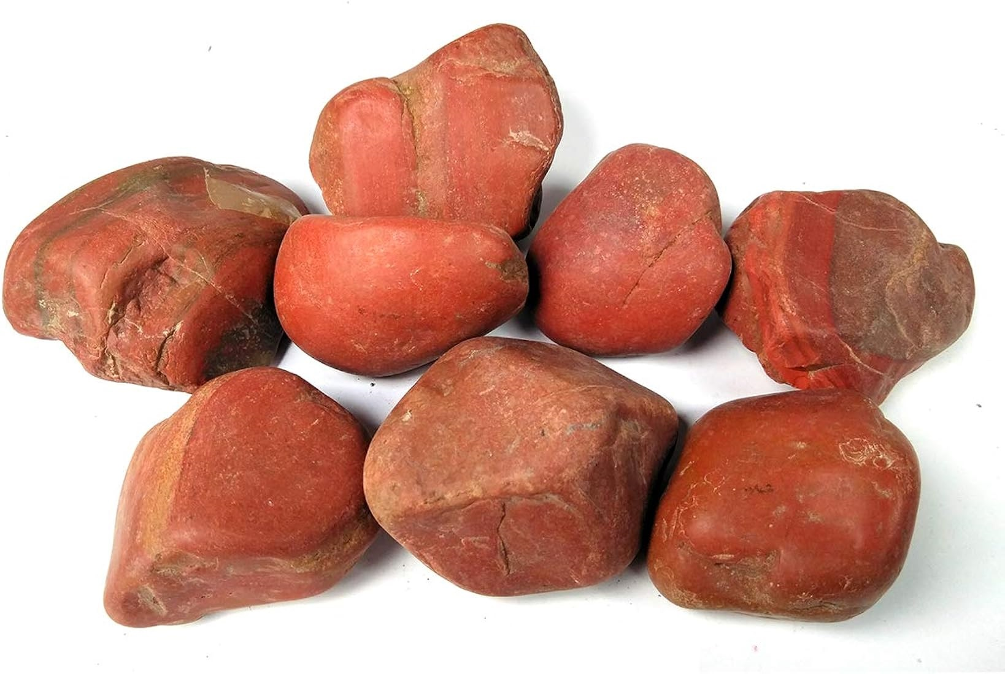

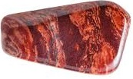

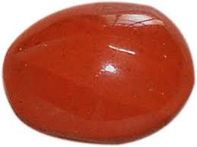

**VERITIES: - There are numerous varieties of jasper, each with its own unique colour and pattern. Some popular ones include:**

**1. Red Jasper: Rich red to terracotta colours with streaks or bands of black or dark brown.**

**2. Green Jasper: Various shades of green, often with mottled or streaked patterns.**

**3. Yellow Jasper: Yellow to mustard-coloured with varying patterns.**

**4. Picture Jasper: Features scenic or landscape-like patterns, often resembling desert scenes or wood grain.**

**5. Brecciated Jasper: Contains broken or fragmented patterns due to the inclusion of angular fragments in the jasper.**

**6. Ocean Jasper: Known for its vibrant orbicular patterns resembling ocean waves.**

**7. Leopard Skin Jasper: Has a spotted or mottled pattern resembling the coat of a leopard.**

**OCCURRENCE: - Jasper is formed through the deposition of silica-rich solutions within fissures or cavities in sedimentary and volcanic rocks. It often occurs in association with other minerals and can be found worldwide. Some notable locations for jasper deposits include the United States (particularly the American Southwest), India, Russia, Madagascar, Australia, and Germany.**

**GEOLOGY: Jasper is typically formed in hydrothermal environments, where silica-rich fluids deposit minerals in cracks and voids within host rocks. The colors and patterns in jasper are the result of various mineral impurities and environmental conditions during formation.**

**USES: - Jasper has been used for a wide range of purposes:**

**1. Jewellery: Jasper is commonly used in jewellery, including cabochons, beads, and pendants.**

**2. Ornamental Items: It's used to create decorative items such as carvings, bookends, and vases.**

**3. Healing and Spiritual Practices: Some people believe that jasper has metaphysical properties, such as promoting balance and grounding.**

**4. Lapidary: Jasper is a favourite among lapidaries and gem cutters who create custom designs.**

**5. Gifts and Souvenirs: Due to its wide variety of colours and patterns, jasper is often used in gift and souvenir items.**

**METAPHYSICAL PROPERTIES: - In metaphysical and healing traditions, jasper is believed to have various properties, although it's important to note that these beliefs are not scientifically proven:**

**1. Grounding and Stability: Jasper is often associated with grounding energies and promoting stability in one's life.**

**2. Protection: Some believe that jasper can provide protection from negative energies and promote a sense of security.**

**3. Balancing Energies: Different varieties of jasper are thought to have specific properties. For example, red jasper may enhance physical strength and vitality, while green jasper may support emotional balance.**

**4. Spiritual Connection: Jasper is sometimes used in meditation and spiritual practices to enhance one's connection with the Earth and the spiritual realm.**

**STARS STONE**

**INTRODUCTION: - The term "starstone" usually refers to gemstones that exhibit asterism, a phenomenon where they display a star-like pattern of light when cut into cabochon shapes. The gemstone with the technical name "Asteria" is likely referring to a specific variety of starstone.**

**Asteria or Starstones are primarily composed of microcrystalline quartz, specifically a form of cryptocrystalline or chalcedony.**

**Asteria or Starstones exhibit asterism, which is the optical phenomenon that gives them the star-like effect. This effect is caused by the reflection of light off needle-like or fibrous inclusions within the stone.**

**IDENTIFICATION PROPERTIES:-**

|  |  |
| --- | --- |
| **Chemical Formula:** | **Silicon dioxide (SiO2),** |
| **Crystal Structure:** | **Hexagonal** |
| **Colour:** | **Shades of gray, black, or brown** |
| **Lustre:** | **Silky to vitreous** |
| **Transparency:** | **Transparent to Translucent** |
| **Fracture** | **Fibrous or splintery fracture** |
| **Cleavage:** | **No cleavage** |
| **Hardness:** | **5.5 to 6.5** |
| **Density:** | **2.64 to 2.71 g/cm³** |
| **Refractive Index:** | **1.76 to 1.78** |
| **Double Refraction:** | **0.004 to 0.016** |
| **Fluorescence:** | **Fluorescence gemstone, ranging from blue and green to orange and red.** |

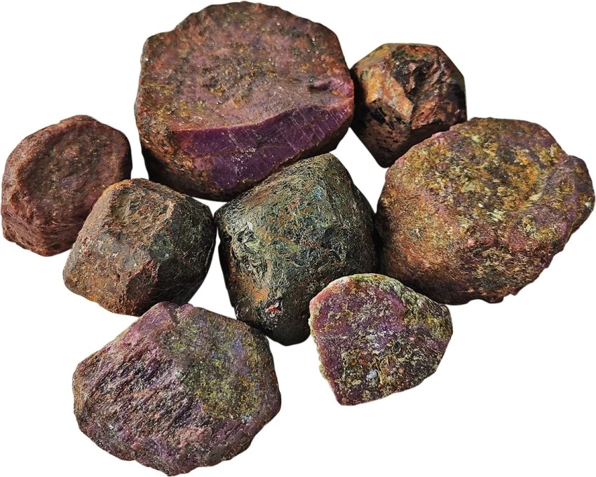

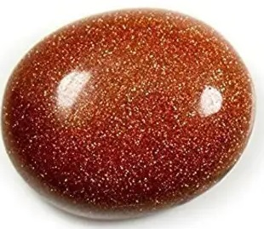

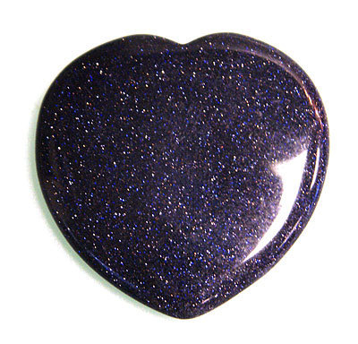

**OCCURRENCE: - Gemstones that can exhibit asterism, such as star sapphires and star rubies, are found in various parts of the world. For example, star sapphires are often found in countries like Sri Lanka, Thailand, and Myanmar (Burma).**

**VARIETIES:- The term "Asteria" typically refers to the star-like optical effect seen in certain gemstones rather than a specific mineral variety. Common gemstones that can exhibit asterism include:**

1. **Star Ruby: A variety of ruby that displays a star-like effect, often in shades of red.**
2. **Star Sapphire: A type of sapphire that displays a star effect, usually in blue, but also in various colors.**

**GEOLOGY:- Asteria or starstones are typically found in metamorphic rocks, particularly in regions with a history of silicification and alteration of existing minerals. The formation of asterism is the result of fine parallel inclusions within the quartz fibers.**

**USES:- Asteria or Starstones gemstones are used many ways**

1. **Jewellery: Asteria or starstones are often used in jewelry, particularly in cabochon-cut forms for rings, pendants, and earrings, to highlight their star-like optical effect.**
2. **Carvings and Decorative Items: They can also be carved into various shapes for decorative purposes.**
3. **Healing Practices: Some individuals use Asteria starstones in holistic healing practices, such as crystal therapy and meditation.**
4. **Collectibles: High-quality Asteria starstones are collectible items among gemstone enthusiasts and collectors.**

**METAPHYSICAL PROPERTIES:- Asteria or starstones, like other star gemstones, are often associated with metaphysical properties, including:**

1. **Protection: They are believed to provide protection against negative energies.**
2. **Guidance: Some people use them as talismans for guidance and insight.**
3. **Spiritual Connection: Asteria starstones are thought to enhance one's spiritual connection and intuition.**

**TIGER’S EYES**

**INTRODUCTION: - Tiger's eye is a chatoyant gemstone, which means it has a silky, lustrous appearance that resembles the eye of a tiger. It is typically brown to golden-brown in colour, with bands of chatoyant fibres that can give it a shimmering effect when viewed from different angles.**

**Tiger's eye is a form of quartz that often contains parallel mineral fibers of crocidolite, which is a type of asbestos. The transformation of crocidolite into quartz gives tiger's eye its unique appearance.**

**IDENTIFICATION PROPERTIES:-**

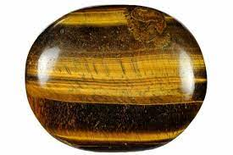

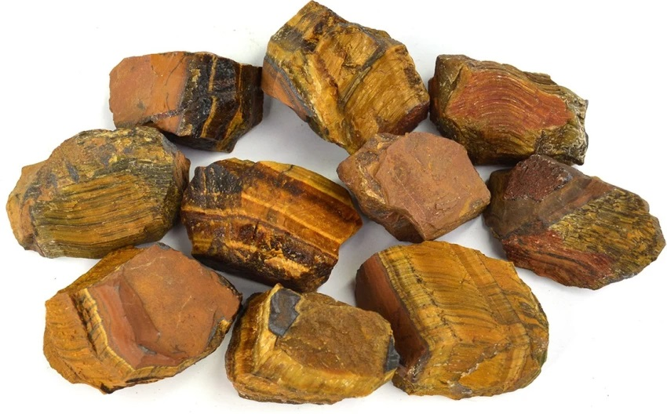

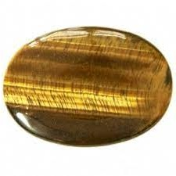

|  |  |
| --- | --- |
| **Chemical Formula:** | **Silicon dioxide (SiO2),** |
| **Crystal Structure:** | **Trigonal** |
| **Colour:** | **Distinct golden to reddish-brown colour** |
| **Lustre:** | **Silky** |
| **Transparency:** | **Opaque** |
| **Fracture** | **Splintery fracture** |
| **Cleavage:** | **No cleavage** |
| **Hardness:** | **5.5-6.5** |
| **Density:** | **2.64 to 2.69 g/cm³** |
| **Form** | **Microcrystalline quartz** |
| **Refractive Index:** | **1.5 to 1.6** |
| **Double Refraction:** | **None** |
| **Fluorescence:** | **None** |

**OCCURAANCES: Tiger's Eye is found in various parts of the world, including South Africa, Australia, the United States, India, and Thailand.**

**VARIETIES:- Different varieties of Tiger’s Eyes are as follows**

**1. Golden Tiger's Eye: The most common variety, displaying a golden to yellowish-brown color.**

**2. Red Tiger's Eye: Features a reddish-brown to maroon color.**

**3. Blue Tiger's Eye (Hawk's Eye): Known for its blue-gray to blue-green color.**

**Geology:- Tiger's Eye forms in metamorphic rocks, particularly those with a history of silicification and alteration of minerals. It results from the replacement of asbestos by quartz.**

**METAPHYSIS: - Tiger's Eye has various metaphysical associations, including:**

1. **Protection: Believed to provide protection against negative energies.**
2. **Courage and Confidence: Thought to enhance courage, self-confidence, and willpower.**
3. **Balance and Harmony: Associated with promoting balance and harmony in life.**
4. **Focus and Clarity: Used for improving concentration and decision-making.**

**USES:**

1. **Jewelry: Commonly used in jewelry, including cabochons for rings, pendants, and earrings.**
2. **Carvings and Decorative Items: Carved into various shapes for decorative purposes.**
3. **Healing Practices: Used in holistic healing practices, such as crystal therapy and meditation.**
4. **Gifts and Souvenirs: Often used as gifts or souvenirs.**

**AQUA MARINE**

**INTRODUCTION: - Aquamarine is the blue to green blue gemstone variety of beryl.  Aquamarine is known for its blue to greenish-blue hues, which can vary in intensity from pale to vibrant. The color is due to trace amounts of iron present in the crystal structure. The gemstone can be transparent to translucent, with higher-quality stones exhibiting greater transparency.**

**IDENTIFICATION PROPERTIES:-**

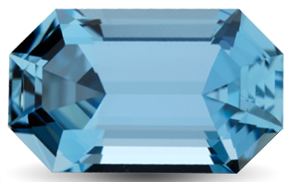

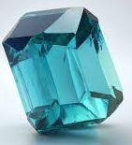

|  |  |
| --- | --- |
| **Chemical Formula:** | **Be3Al2(SiO3)6** |
| **Crystal Structure:** | **Hexagonal** |
| **Colour:** | **Pale blue to blue-green colour** |
| **Lustre:** | **Vitreous** |
| **Transparency:** | **Transparent to Translucent** |
| **Fracture** | **Conchoidal** |
| **Cleavage:** | **No cleavage** |
| **Hardness:** | **7.5 to 8.0** |
| **Density:** | **2.65 to 2.80 g/cm³** |
| **Form:** | **Prismatic crystals** |
| **Refractive Index:** | **1.57 to 1.59** |
| **Double Refraction:** | **Week birefringence** |
| **Fluorescence:** | **None** |

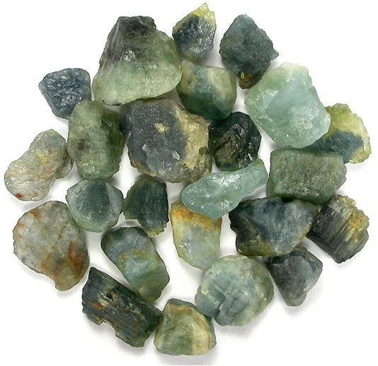

**OCCURAANCES: - Aquamarine is found in various parts of the world, including Brazil, Madagascar, Afghanistan, Pakistan, Nigeria, Mozambique, and the United States.**

**VARIETIES: - Aquamarine is typically categorized by its colour and quality.**

1. **Santa Maria Aquamarine: A rare and highly prized variety with an intense, pure blue colour, originally from Brazil.**
2. **Maxixe Aquamarine: This variety is a deep blue but fades upon prolonged exposure to light.**

**GEOLOGICAL OCCURRENCE:- Aquamarine forms through a combination of geological processes that involve the right conditions of temperature, pressure, and chemical elements. The formation of aquamarine typically occurs in pegmatites and hydrothermal veins. Aquamarine forms in pegmatite veins within granite and metamorphic rocks. It is often associated with other beryl varieties, such as emerald and morganite. The gemstone's blue colour is the result of iron ions in its crystal lattice.**

**METAPHYSICS: - In metaphysical and healing traditions, aquamarine is associated with qualities such as:**

**1. Calmness and Serenity:- Aquamarine is believed to bring a sense of peace and tranquility.**

**2. Communication:- It is thought to enhance communication skills and self-expression.**

**3. Courage and Protection: Some believe it provides courage and protection during travel, especially over water.**

**USES:-**

1. **Jewelry:- Aquamarine is highly valued in jewelry, especially in rings, necklaces, earrings, and bracelets.**
2. **Carvings and Decorative Items: It is used for carved gemstone art pieces.**
3. **Collector's Gem: Fine-quality aquamarines are sought after by gemstone collectors.**
4. **Healing Practices: Some individuals use aquamarine in crystal healing and meditation.**
5. **Engagement Rings: Due to its durability and symbolism of tranquility, aquamarine is occasionally used in engagement rings.**

**LAPIS LAZULI**

**INTRODUCTION: - Lapis Lazuli is known for its rich blue color, ranging from deep blue to light blue. It often contains golden pyrite inclusions and white calcite veins.**

**Lapis Lazuli is not a mineral but a rock composed of several minerals. The main components include lazurite (responsible for the blue color), pyrite (golden specks), calcite (white veins), and smaller amounts of other minerals like sodalite and hauyne. The blue color in Lapis Lazuli is primarily due to lazurite, while the golden specks come from pyrite.**

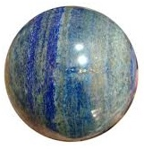

**IDENTIFICATION PROPERTIES:-**

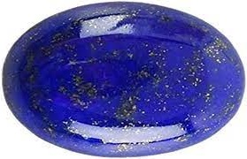

|  |  |
| --- | --- |
| **Chemical Formula:** | **silicon dioxide (SiO2),** |
| **Crystal Structure:** |  |
| **Colour:** | **Deep blue to light blue** |
| **Lustre:** | **Dull to waxy luster** |
| **Transparency:** | **Opaque** |
| **Fracture** | **Uneven fracture** |
| **Cleavage:** | **No cleavage** |
| **Hardness:** | **5.5** |
| **Density:** | **2.4 to 2.9 g/cm³** |
| **Refractive Index:** | **1.5 to 1.55** |
| **Double Refraction:** | **None** |
| **Fluorescence:** | **None** |

**OCCURANCES:- Lapis Lazuli is found in various regions around the world, including:**

1. **Afghanistan: The most famous source of high-quality Lapis Lazuli, particularly from the Sar-e-Sang mines.**
2. **Pakistan: Another significant source of Lapis Lazuli, often referred to as Pakistani Lapis.**
3. **Chile: Known for producing Lapis Lazuli with varying shades of blue.**
4. **Russia: The Ural Mountains region is a source of Lapis Lazuli.**
5. **United States: Lapis Lazuli has been found in Colorado and California.**

**VARIETIES:- Lapis Lazuli is typically categorized based on the quality and intensity of its blue color. Varieties include:**

1. **Royal Blue Lapis: High-quality Lapis Lazuli with a deep and intense blue color.**
2. **Afghan Lapis: Lapis Lazuli from Afghanistan, considered among the finest.**
3. **Chilean Lapis: Lapis Lazuli from Chile, known for its varying shades of blue.**

**GEOLOGY:- Lapis Lazuli forms in metamorphic rocks, especially in limestone or marble that has undergone metamorphism. The blue color results from the presence of lazurite, while the golden flecks are due to pyrite.**

**METAPHYSICS: In metaphysical and healing traditions, Lapis Lazuli is associated with various qualities, including:**

1. **Inner Wisdom:- It is believed to enhance inner wisdom, self-awareness, and insight.**
2. **Communication:- Lapis is thought to improve communication skills, self-expression, and creativity.**
3. **Protection:- Some use Lapis Lazuli as a protective stone, especially against negative energies.**

**USES:-**

1. **Jewelry: Lapis Lazuli has been used in jewelry for thousands of years, often carved into cabochons for rings, necklaces, and earrings.**
2. **Art and Decor: It is used in art, sculpture, and decorative objects.**
3. **Pigments: Ground Lapis Lazuli has historically been used to create ultramarine pigment for paintings.**
4. **Metaphysical and Spiritual Practices: Lapis Lazuli is used in meditation, energy work, and crystal healing.**

**AMETHYST**

**INTRODUCTION: - Amethyst is a mineral that belongs to the**[**quartz**](https://geologyscience.com/minerals/quartz/)**family, known for its purple to violet hue. Amethyst is a variety of the mineral quartz and has the same chemical formula as quartz, which is SiO2.**

**The purple colour of amethyst is due to the presence of trace amounts of**[**iron**](https://geologyscience.com/minerals/iron/)**and**[**manganese**](https://geologyscience.com/ore-minerals/manganese-ore/)**in the crystal lattice. The exact composition of amethyst can vary depending on the specific deposit and the conditions under which it formed, but the basic chemical formula remains the same.**

**Pleochroism: Amethyst exhibits weak pleochroism, meaning that it can display different colours when viewed from different angles. However, this property is not very noticeable in most specimens. Dispersion: Amethyst has relatively low dispersion, meaning that it does not break light into its component colours very strongly.**

**IDENTIFICATION PROPERTIES:-**

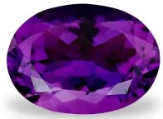

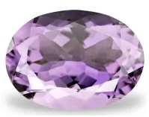

|  |  |
| --- | --- |
| **Chemical Formula:** | **Silicon dioxide (SiO2),** |
| **Crystal Structure:** | **Tetragonal** |
| **Colour:** | **Purple or Pale lilac to deep violet** |
| **Lustre:** | **Vitreous** |
| **Transparency:** | **Transparent to Translucent** |
| **Fracture** | **Conchodial** |
| **Cleavage:** | **No cleavage** |
| **Hardness:** | **7.0** |
| **Density:** | **2.65 to 2.80 g/cm³** |
| **Form:** | **Cluster of Prismatic crystals** |
| **Refractive Index:** | **1.54 to 1.55** |
| **Double Refraction:** | **Present** |
| **Fluorescence:** | **Present** |

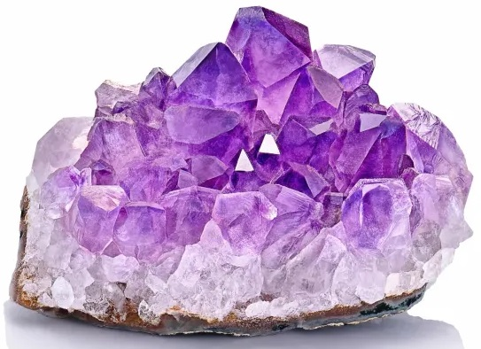

**OCCURANCES:- Amethyst can be found in various locations around the world, including Brazil, Uruguay, Zambia, Madagascar, Russia, India, and the United States (specifically, Arizona and North Carolina).**

**VARIETIES:- Amethyst is primarily categorized based on its colour and quality. Varieties include:**

1. **Siberian Amethyst: Known for its deep, intense purple colour, originally from Siberia (Russia).**
2. **Rose de France Amethyst: A pale to light purple variety, often with a pinkish hue.**
3. **Ametrine: A rare variety that combines both amethyst and citrine colours in a single crystal.**

**GEOLOGY: - Amethyst is a variety of quartz and typically forms in geodes within igneous rocks or in hydrothermal veins. The purple color results from irradiation and trace amounts of iron within the quartz.**

**METAPHYSIS:- In metaphysical and healing traditions, Amethyst is associated with various qualities, including:**

1. **Spirituality: Amethyst is considered a stone of spirituality, enhancing one's connection to higher states of consciousness.**
2. **Calming and Stress Relief: It is believed to promote calmness, balance, and stress relief.**
3. **Intuition and Insight: Some use Amethyst to enhance intuition and spiritual insight.**

**USES:-**

1. **Jewelry: Amethyst is widely used in various jewelry pieces, including rings, necklaces, earrings, and bracelets.**
2. **Carvings and Decorative Items: It is carved into various shapes for decorative purposes.**
3. **Healing Practices: Amethyst is used in crystal healing, meditation, and energy work.**
4. **Birthstone: Amethyst is the birthstone for February and is often incorporated into birthstone jewelry.**
5. **Collector's Gem: Fine-quality Amethyst specimens are sought after by gemstone enthusiasts and collectors.**

**TURQUOISE**

**INTRODUCTION: - Turquoise is an opaque stone that ranges from blue to green in colour, depending on the amount of**[**iron**](https://geologyscience.com/minerals/iron/)**and copper it contains. The most valuable turquoise stones generally have a smoother, solid colour, while many stones have brown veins throughout.**

**The word turquoise comes from a French word meaning “Turkish,” likely because the stone was introduced to Medieval Europe by Turkish sources. This mineral usually occurs in massive or microcrystalline forms, as encrustations or nodules, or in veins. Crystals are rare; when found, they occur as short, often transparent prisms.**

**Turquoise occurs in arid environments as a secondary mineral probably derived from the decomposition of**[**apatite**](https://geologyscience.com/minerals/apatite/)**and some copper sulfides. Turquoise is a hydrous phosphate mineral. Its chemical formula is often expressed as CuAl6(PO4)4(OH)8·4H2O, indicating the presence of copper, aluminum, phosphorus, oxygen, and water.**

**IDENTIFICATION PROPERTIES:-**

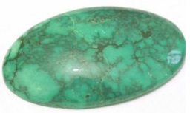

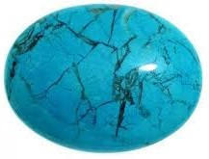

|  |  |
| --- | --- |
| **Chemical Formula:** | **Hydrous phosphate of aluminium CuAl6(PO4)4(OH)8·4H2O** |
| **Crystal Structure:** | **Triclinic** |
| **Colour** | **Blue-green to green colour** |
| **Lustre:** | **Waxy and Subvitreous** |
| **Transparency:** | **Opaque** |
| **Fracture** | **Conchoidal to Uneven** |
| **Cleavage:** | **No cleavage** |
| **Hardness:** | **5 to 6** |
| **Density:** | **2.6 to 2.8 g/cm³** |
| **Form** | **Cryptocrystalline massive** |
| **Refractive Index:** | **1.61 to 1.65** |
| **Double Refraction:** | **None** |
| **Fluorescence:** | **None** |

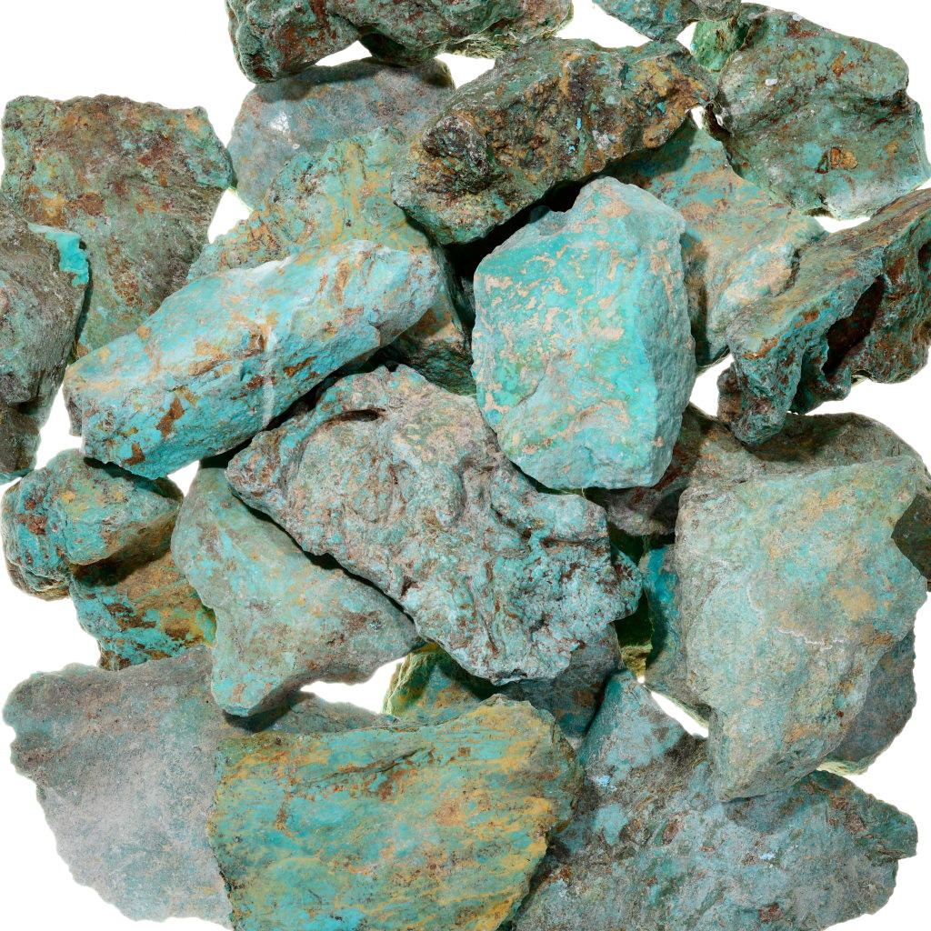

**OCCURANCES:-Turquoise is found in various parts of the world, including:**

1. **South western United States: Regions like Arizona and New Mexico are known for producing high-quality turquoise.**
2. **Iran: Iranian turquoise, particularly from Neyshabur, is highly regarded.**
3. **China: Turquoise is mined in various provinces of China.**
4. **Egypt: The Sinai Peninsula is a historical source of turquoise.**
5. **Mexico: Turquoise is also found in Mexico, with notable deposits in Sonora and Zacatecas.**

**VARIETIES: - Varieties of turquoise may be named after their mining locations or other characteristics. Some examples include:**

**Sleeping Beauty Turquoise: Mined in Arizona, it is known for its robin's egg blue colour.**

**Persian Turquoise: Renowned for its deep blue colour, often with a spider web matrix.**

**Bisbee Turquoise: Comes from the Bisbee mine in Arizona and features rich blue and green colours.**

**Kingman Turquoise: Mined in Arizona, known for its bright blue colour and pyrite inclusions.**

**GEOLOGY: - Turquoise typically forms in arid or semi-arid regions in association with copper deposits. It often occurs in veins or as nodules within host rocks such as limonite or sandstone.**

**METAPHYSICS: In metaphysical and healing traditions, turquoise is associated with various qualities, including:**

1. **Protection: - Turquoise is believed to provide protection against negative energies.**
2. **Communication:- It is thought to enhance communication and self-expression.**
3. **Healing and Balance:- Some use turquoise for physical and emotional healing and to promote balance and harmony.**

**USES:-**

1. **Jewellery: Turquoise has been used in jewellery for thousands of years, especially in Native American and Southwestern jewellery designs.**
2. **Art and Decor: It is used in art, sculpture, and decorative objects.**
3. **Historical and Cultural Significance: Turquoise holds cultural and historical significance in many societies, including Native American tribes.**
4. **Collector's Gem: Fine-quality turquoise specimens are sought after by gemstone enthusiasts and collectors.**

**SERPENTINE**

**INTRODUCTION: - Serpentine is a group of minerals with a complex chemical composition. It is primarily composed of hydrous magnesium iron silicate. The specific composition can vary among different serpentine minerals.**

**Serpentine comes in various colors, including green, yellow-green, brown, black, and white. The green varieties are the most common. Apart from the main members of Antigorite and Chrysotile, there is usually no distinction between individual members except for scientific study and classification.**

**Antigorite generally represents more solid forms, and Chrysotile often represents fibrous forms, especially asbestos. Chrysotile divides the four-membered mineral into its subclass with its crystallization, and the clinocotylot is the most common form of Chrysotile to date. In this formula, X will be one of the following metals: magnesium,**[**iron**](https://geologyscience.com/minerals/iron/)**, nickel,** [**aluminum**](https://geologyscience.com/ore-minerals/aluminum-ore/)**, zinc, or manganese and Y will be silicon, aluminum, or iron.**

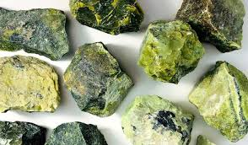

**IDENTIFICATION PROPERTIES:-**

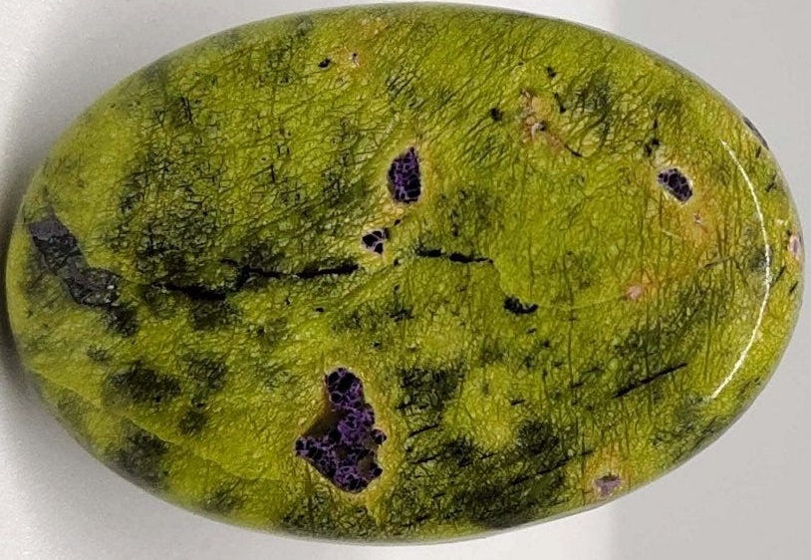

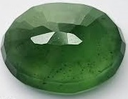

|  |  |
| --- | --- |
| **Chemical Formula:** | **Mg3Si2O5(OH)4** |
| **Crystal Structure:** | **Monclinic** |
| **Colour:** | **Green** |
| **Lustre:** | **Waxy or greasy** |
| **Transparency:** | **Translucent to Opaque** |
| **Fracture** | **Conchodial** |
| **Cleavage:** | **Poor to Perfect** |
| **Hardness:** | **3 to 6** |
| **Density:** | **2.5 to 2.6 g/cm³** |
| **Refractive Index:** | **1.538 to 1.567** |
| **Double Refraction:** | **.001 to .010** |
| **Fluorescence:** | **None** |

**OCCURANCES: Serpentine can be found in various regions around the world, including:**

1. **United States: It occurs in California, Pennsylvania, Vermont, and other states.**
2. **Italy: Serpentine is known from regions like Val d'Aosta.**
3. **New Zealand: Serpentine deposits exist in parts of the South Island.**

**VARIETIES:- Serpentine is a group of minerals, and it includes several distinct varieties, such as:**

1. **Bowenite: A translucent to opaque, green variety of serpentine.**
2. **Williamsite: A rare, dark green to black variety of serpentine often used for carving.**
3. **Noble Serpentine: A fine-grained, light green to yellowish-green variety suitable for carving and jewelry.**

**GEOLOGY:- Serpentine minerals form in metamorphic rocks, particularly in areas with high magnesium content. They are often associated with the serpentine group of rocks, which are typically found near tectonic plate boundaries.**

**Metaphysics:- In metaphysical and healing traditions, serpentine is associated with various qualities, including:**

1. **Healing: Serpentine is believed to have healing properties and is used for emotional balance and protection.**
2. **Transformation: It is thought to aid in personal transformation and growth.**
3. **Connection to Nature: Some use serpentine to enhance their connection to nature and the Earth's energies.**

**USES:-**

1. **Jewelry: Serpentine is occasionally used in jewelry, especially the more attractive and translucent varieties.**
2. **Carvings and Sculptures: It is often used for carving figurines, ornaments, and small sculptures.**
3. **Architectural and Decorative Stones: Serpentine is sometimes used in architecture and for decorative purposes.**
4. **Metaphysical and Holistic Practices: It is used in crystal healing, meditation, and energy work.**

**ROSE QUARTZ**

**INTRODUCTION: - Rose**[**quartz**](https://geologyscience.com/minerals/quartz/)**is a pink-colored variety of the mineral quartz (SiO2), often considered one of the most popular and recognizable gemstones. It derives its name from its delicate rose-pink hue, which can range from pale to more intense shades.**

**Rose quartz is a macrocrystalline form of quartz, meaning it consists of larger visible crystals. Its coloration is attributed to trace amounts of**[**titanium**](https://geologyscience.com/ore-minerals/titanium-ore/)**,**[**iron**](https://geologyscience.com/minerals/iron/)**, or**[**manganese**](https://geologyscience.com/ore-minerals/manganese-ore/)**within the crystal structure. The colour can vary due to different concentrations of these impurities. Its pink colour is attributed to trace amounts of titanium, iron, or manganese.**

**IDENTIFICATION PROPERTIES:-**

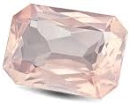

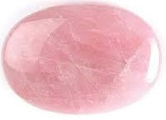

|  |  |
| --- | --- |
| **Chemical Formula:** | **Silicon dioxide (SiO2),** |
| **Crystal Structure:** | **Trigonal** |
| **Colour:** | **Pink to rosy red** |
| **Lustre:** | **Vitreous**  E:\Personal Data\natural-rose-quartz-gemstone.jpg |
| **Transparency:** | **Transparent to Translucent** |
| **Fracture** | **Conchodial** |
| **Cleavage:** | **No cleavage** |
| **Hardness:** | **7.0** |
| **Density:** | **2.6 to 2.7 g/cm³** |
| **Form** | **Micro cryptocrystalline** |
| **Refractive Index:** | **1.544 to 1.553** |
| **Double Refraction:** | **Present** |
| **Fluorescence:** | **Weak fluorescent** |

**OCCURANCES:- Rose Quartz can be found in various regions around the world, including:**

1. **Brazil: Brazil is a significant source of high-quality Rose Quartz.**
2. **Madagascar: Madagascar also produces notable Rose Quartz specimens.**
3. **United States: States like South Dakota, Colorado, and Maine have Rose Quartz deposits.**
4. **Namibia: Rose Quartz is found in some regions of Namibia, Africa.**

**VARIETIES:- There are no specific varieties of Rose Quartz, but its quality can vary based on color saturation and transparency. The most prized is a deep, even pink color with excellent transparency.**

**GEOLOGY:- Rose Quartz typically forms in pegmatite veins within granite or in hydrothermal veins. It often occurs alongside other minerals like amethyst, citrine, and smoky quartz.**

**METAPHYSICS: - In metaphysical and healing traditions, Rose Quartz is associated with various qualities, including:**

1. **Love and Compassion: Rose Quartz is often called the "Stone of Love" and is believed to promote love, compassion, and emotional healing.**
2. **Self-Confidence: It is thought to enhance self-confidence and self-esteem.**
3. **Emotional Balance: Rose Quartz is used to balance emotions and promote inner peace.**
4. **Heart Chakra: It is associated with the heart chakra and is used for heart-centered meditation and healing.**

**USES:-**

1. **Jewelry: Rose Quartz is widely used in jewelry, especially for beads, cabochons, and carved figurines.**
2. **Carvings and Decorative Items: It is carved into hearts, animals, and other shapes for decorative and healing purposes.**
3. **Holistic Healing: Rose Quartz is used in crystal healing practices, energy work, and meditation.**
4. **Gifts and Souvenirs: It is often given as a gift, especially on occasions related to love and friendship.**

**GARNET**

**INTRODUCTION: - Garnet is a group of silicate minerals with a common crystal structure but varying chemical compositions. They are typically composed of aluminum, silicon, and oxygen, along with varying amounts of other elements such as iron, calcium, and magnesium.**

**The most commonly found garnets are typically red to reddish-brown in colour, but they can also occur in shades of orange, yellow, green, purple, and even colorless varieties. The diverse range of colours is due to the different elements present in the crystal structure.**

**Garnets have the general chemical formula A 3B 2Si 3O 12, where A is a divalent cation (Fe 2+, Ca 2+, Mg 2+, Mn 2+) and B is a trivalent cation (Fe 3+, Al 3+, Cr 3+). The end-members pyrope, almandine, and spessartine form one solid solution series, while the end-members grossular, andradite and uvarovite form another. In some cases, garnets can display chatoyancy, or a “cat’s eye” effect, caused by the presence of parallel fibrous or needle-like inclusions that reflect light in a narrow band.**

**IDENTIFICATION PROPERTIES:-**

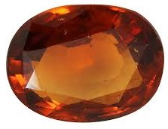

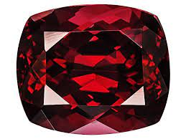

|  |  |
| --- | --- |
| **Chemical Formula:** | **A 3B 2Si 3O 12** |
| **Crystal Structure:** | **Tetrahedron** |
| **Colour:** | **Red, Green, Orange, Yellow, Brown and Black** |
| **Lustre:** | **Vitreous to Resinous** |
| **Transparency:** | **Transparent to Translucent** |
| **Fracture** | **Conchoidal** |
| **Cleavage:** | **No cleavage** |
| **Hardness:** | **6.7 to 7.5** |
| **Density:** | **3.1 to 4.3 g/cm³** |
| **Form** | **Crystal** |
| **Refractive Index:** | **1.72 to 1.89** |
| **Double Refraction:** | **Present** |
| **Fluorescence:** | **None** |

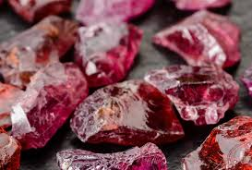

**OCCURANCES:- Garnets can be found in numerous locations worldwide, including:**

1. **India:- Known for producing red and green garnets.**
2. **Mozambique:- A significant source of high-quality red garnets.**
3. **Brazil:- Produces a variety of garnet types.**
4. **United States:- Garnets are found in states like Arizona, California, and Idaho.**
5. **Madagascar:- Known for its pink, orange, and green garnets.**

**VARITIES:- Garnets are divided into several species and varieties, including:**

1. **Almandine: Red to violet-red garnet, the most common type.**
2. **Pyrope: Deep red to purplish-red garnet.**
3. **Spessartine: Orange to reddish-brown garnet.**
4. **Grossular: Green to yellow-green garnet, also includes Tsavorite (vivid green) and Hessonite (orange-brown).**
5. **Andradite: Includes Demantoid (green) and Melanite (black).**
6. **Uvarovite: Rare, emerald-green garnet.**

**GEOLOGY:- Garnets can be found in various geological settings, including metamorphic rocks, igneous rocks, and sedimentary rocks. They often form in high-pressure and high-temperature environments.**

**METAPHYSICS:- In metaphysical and healing traditions, garnet is associated with various qualities, including:**

1. **Passion and Energy: Garnet is believed to enhance passion, motivation, and energy.**
2. **Protection: It is thought to offer protection from negative energies.**
3. **Root Chakra: Garnet is associated with the root chakra and is used for grounding and stability.**

**USES:**

1. **Jewelry: Garnets are commonly used in jewelry, including rings, necklaces, earrings, and bracelets.**
2. **Abrasives: Some garnet varieties are used as abrasives in sandpaper and waterjet cutting.**
3. **Industrial Uses: Garnets are used in various industrial applications, including water filtration and abrasive blasting.**
4. **Collectibles: Fine-quality garnets, especially rare varieties like Demantoid, are sought after by gemstone collectors.**

**LABRADORITE**

**INTRODUCTION: - Labradorite is a variety of plagioclase feldspar, a group of minerals composed of sodium, calcium, and aluminum silicates. Its chemical formula is (Na,Ca)[(Si,Al)Al(Si,Al)O8].**

**Labradorite gemstones are a plagioclase mineral. Plagioclase minerals are feldspars that range from pure albite to pure anthorite. The gem labradorite falls into the 50-70% anthorite category with a 50-70% calcium to 30-50% sodium structure. Labradorite is most commonly known for its brilliant flashes of color called labradoressence caused by lamellar twinning inside the crystal. These twin lamellae structures are compatible at high temperatures, but not at low temperatures, resulting in separation and layering as the gemstone is formed.**

**The extra colors you see in labradorite are caused by refracted light traveling at different speeds through the layers and coming out as a different wave length. A rare variety of labradorite--called spectrolite--displays a richer, fuller spectrum of colours than most.**

**Play of Colors or iridescence, known as "labradorescence," is caused by light interference from thin, alternating layers of different feldspar minerals within the crystal structure.**

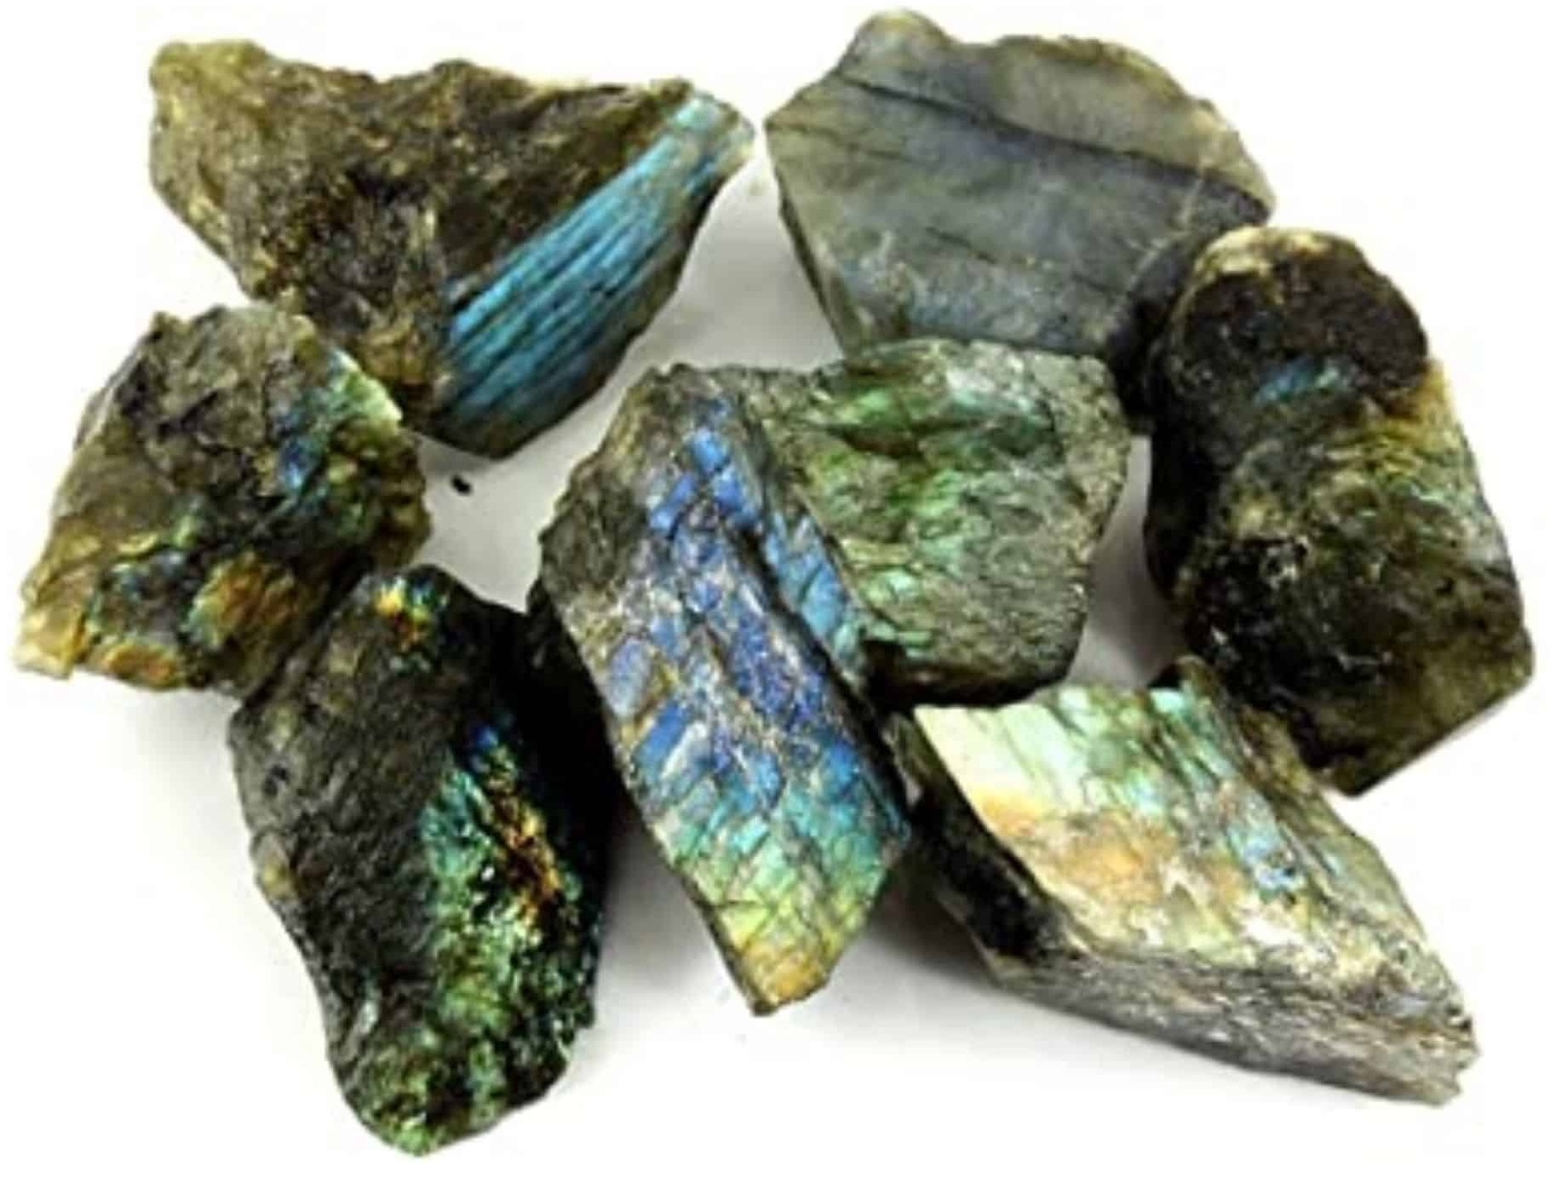

**IDENTIFICATION PROPERTIES:-**

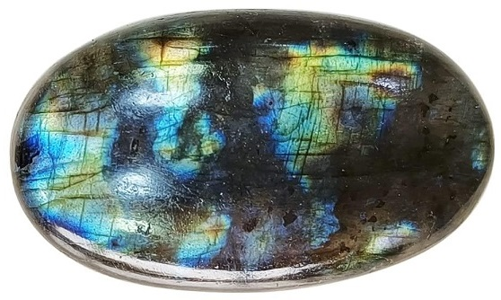

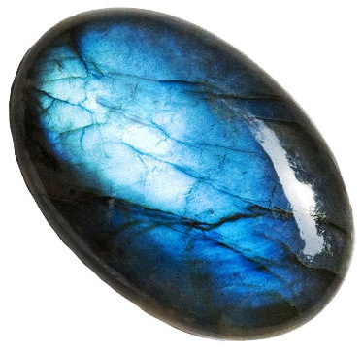

|  |  |
| --- | --- |
| **Chemical Formula:** | **Na(AlSi3O8)Ca(Al2Si2O8)** |
| **Crystal Structure:** | **Triclinic** |
| **Colour:** | **Shades of blue, green, yellow and orange with blue flash** |
| **Lustre:** | **Vitreous to Pearly** |
| **Transparency:** | **Translucent to Semi-translucent** |
| **Fracture** | **fibrous or splintery fracture** |
| **Cleavage:** | **Perfect cleavage in two direction** |
| **Hardness:** | **6.0 to 6.5** |
| **Density:** | **2.68 to 2.72 g/cm³** |
| **Refractive Index:** | **1.560 TO 1.568** |
| **Double Refraction:** | **0.006 to 0.012** |
| **Fluorescence:** | **Present** |

**OCCURANCES:- Labradorite is found in various regions around the world, including:**

1. **Canada: Labradorite was originally discovered in Labrador, Canada, and is named after the region.**
2. **Madagascar: Known for producing high-quality labradorite with intense labradorescence.**
3. **Finland: Finnish labradorite, known as Spectrolite, is highly prized for its vibrant colors.**
4. **Norway: Blue labradorite from Norway is another well-known variety.**

**VARIETIES:- Labradorite itself is a variety of plagioclase feldspar, but there are no specific varieties within labradorite. Instead, the gem is valued for the quality and intensity of its labradorescence.**

**GEOLOGY:- Labradorite is commonly found in igneous rocks, particularly in gabbro, basalt, and anorthosite. It forms when plagioclase feldspar undergoes a process called twinning, which creates the alternating layers responsible for the play of colors.**

**METAPHYSICS:- In metaphysical and healing traditions, labradorite is associated with various qualities, including:**

1. **Transformation: - Labradorite is believed to enhance personal transformation, change, and growth.**
2. **Intuition and Psychic Abilities: - It is thought to stimulate intuition, enhance psychic abilities, and strengthen the aura.**
3. **Protection:- Some use labradorite as a protective stone against negative energies and psychic attacks.**

**USES:**

1. **Jewelry: Labradorite is commonly used in jewelry, especially for cabochons, beads, and pendants.**
2. **Art and Decor: It is used in art, sculpture, and decorative objects.**
3. **Meditation and Spiritual Practices: Labradorite is used in meditation and energy work to enhance spiritual connections.**
4. **Gifts: It is often given as a gift to symbolize transformation and personal growth.**

**MALACHITE**

**INTRODUCTION: - Malachite is a copper carbonate mineral that has the chemical formula Cu2CO3(OH)2. Malachite is a popular green mineral known for its distinctive color and unique banded patterns.**

**Malachite is usually found as botryoidal or encrusting masses, often with a radiating fibrous structure and banded in various shades of green. It also occurs as delicate fibrous aggregates and as concentrically banded stalactites. Malachite occurs in the altered zones of copper**[**deposits**](https://geologyscience.com/geology-branches/mining-geology/mineral-deposit/)**, where it is usually accompanied by lesser amounts of**[**azurite**](https://geologyscience.com/gemstone/azurite/)**. It is primarily valued as an ornamental material and**[**gemstone**](https://geologyscience.com/gemstones/)**.**

**IDENTIFICATION PROPERTIES:-**

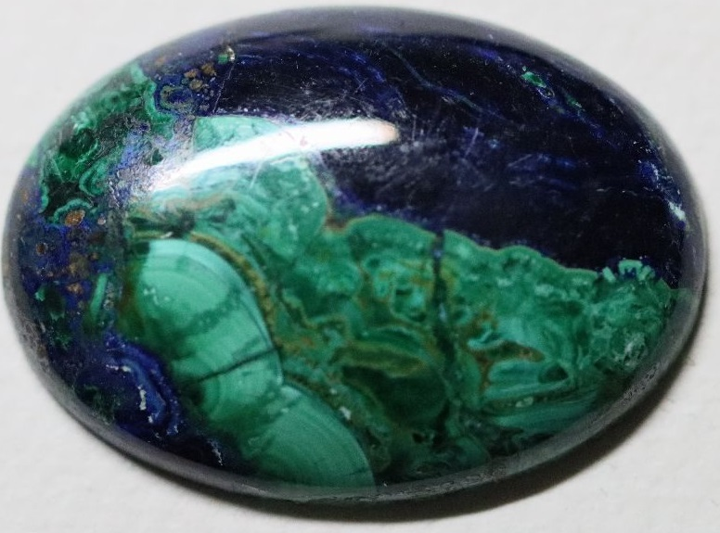

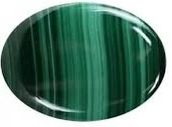

|  |  |
| --- | --- |
| **Chemical Formula:** | **Cu2CO3(OH)2** |
| **Crystal Structure:** | **Monoclinic** |
| **Colour:** | **Light green to deep green** |
| **Lustre:** | **Silky to vitreous** |
| **Transparency:** | **Opaque** |
| **Fracture** | **Conchoidal** |
| **Cleavage:** | **No cleavage** |
| **Hardness:** | **3.5 to 4.0** |
| **Density:** | **3.6 to 4.0 g/cm³** |
| **Form:** | **Botryoidal or stalactitic masses** |
| **Refractive Index:** | **1.655 to1.909** |
| **Double Refraction:** | **0.254** |
| **Fluorescence:** | **None** |



**OCCURANCES:- Malachite is found in various regions around the world, including:**

1. **Congo: Known for producing high-quality malachite specimens.**
2. **Russia: Malachite is found in the Ural Mountains region.**
3. **Australia: Western Australia has notable malachite deposits.**
4. **United States: Malachite is found in states like Arizona and Nevada.**

**VARIETIES:- Malachite itself is a distinct mineral species, but its appearance can vary based on banding patterns, concentric rings, and color intensity. Varieties include:**

1. **Banded Malachite: Characterized by its concentric banding, creating a unique pattern.**
2. **Botryoidal Malachite: Forms in rounded, grape-like clusters.**
3. **Fibrous Malachite: Composed of fine, fibrous crystals.**
4. **Pseudomorphs: Sometimes, malachite pseudomorphs after other minerals, retaining their shape while replacing their composition.**

**GEOLOGY:- Malachite is typically formed through the weathering and oxidation of copper ore deposits, particularly in association with copper minerals like chalcopyrite. It often occurs in the upper zones of copper deposits.**

**METAPHYSICS:- In metaphysical and healing traditions, malachite is associated with various qualities, including:**

1. **Transformation: Malachite is believed to facilitate personal transformation and change.**
2. **Healing: It is thought to have healing properties, especially for emotional healing and spiritual growth.**
3. **Protection: Malachite is used as a protective stone against negative energies and pollution.**

**USES:-**

1. **Jewelry: Malachite is used in jewelry, especially for cabochons, beads, and pendants.**
2. **Carvings and Decorative Items: It is often carved into figurines, ornaments, and decorative objects.**
3. **Art: Malachite has been used in art and architecture, including inlaid table tops and mosaics.**
4. **Metaphysical Practices: Malachite is used in meditation, energy work, and crystal healing.**

**MOON STONE**

**INTRODUCTION: - Moonstone is a type of**[**feldspar**](https://geologyscience.com/minerals/feldspar/)**mineral that has a unique adularescent effect, meaning it displays a shimmering, floating light effect that appears to move across the gemstone’s surface. This phenomenon is caused by light scattering between microscopic layers of albite and**[**orthoclase**](https://geologyscience.com/minerals/orthoclase/)**within the crystal structure.**

**Moonstone is known for its shimmering adularescence, which displays a soft and pearly blue or white glow. Some moonstones may also exhibit colors like peach, gray, or green. Moonstone can contain trace elements such as iron, titanium, and copper, which can affect its color and other physical properties. Insoluble in water and most common acids, but it can be dissolved by hydrofluoric acid.**

**Moonstone can exhibit isomorphism, which means that it can have different chemical compositions while retaining the same crystal structure. This is because different elements can substitute for each other in the crystal lattice.**

**Moonstone can be altered by weathering processes, such as exposure to water, oxygen, and carbon dioxide. This can cause the mineral to break down and form other minerals such as clay.**

**IDENTIFICATION PROPERTIES:-**



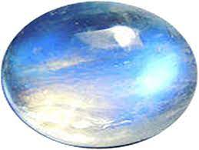

|  |  |
| --- | --- |
| **Chemical Formula:** | **KAlSi3O8** |
| **Crystal Structure:** | **Monoclinic** |
| **Colour:** | **White to colourless** |
| **Lustre:** | **Pearly to vitreous** |
| **Transparency:** | **Translucent to semi-transparent** |
| **Fracture** | **fibrous or splintery fracture** |
| **Cleavage:** | **Two distinct cleavage** |
| **Hardness:** | **6 to 6.5** |
| **Density:** | **2.56 to 2.59 g/cm³** |
| **Refractive Index:** | **1.518 to 1.530** |
| **Double Refraction:** | **0.008** |
| **Fluorescence:** | **None** |

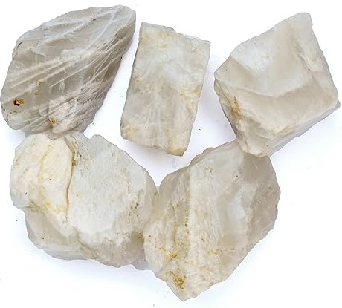

**OCCURANCES:- Moonstone is found in various regions around the world, including:**

1. **India: India is known for producing high-quality blue moonstones.**
2. **Sri Lanka: Sri Lankan moonstones, often called "Ceylon moonstones," are renowned for their color and adularescence.**
3. **Madagascar: Madagascar is another source of fine moonstone specimens.**
4. **Myanmar: Myanmar also produces moonstones.**

**VARIETIES:-**

1. **Rainbow Moonstone: This variety exhibits a range of colors within the adularescent sheen, including blues, pinks, and yellows.**
2. **Blue Moonstone: Blue moonstone has a pronounced blue adularescence.**
3. **Peach Moonstone: Peach moonstone has a soft peachy color with adularescence.**
4. **White Moonstone: White moonstone typically displays a white or silver adularescence.**

**GEOLOGY:- Moonstone forms in pegmatite rocks and is often associated with other feldspar minerals like orthoclase and albite. The shimmering adularescence is created by the interplay of light within the layers of these feldspar minerals.**

**METAPHYSICS:- In metaphysical and healing traditions, moonstone is associated with various qualities, including:**

1. **Feminine Energy: Moonstone is often linked with feminine energy and is said to enhance intuition and emotional balance.**
2. **Protection: It is believed to offer protection, especially during travel.**
3. **Enhanced Creativity: Moonstone is used to stimulate creativity and inspiration.**
4. **Crown Chakra: Moonstone is associated with the crown chakra and is believed to facilitate spiritual growth.**

**USES:-**

1. **Jewelry: Moonstone is commonly used in jewelry, especially for rings, necklaces, earrings, and pendants.**
2. **Carvings and Decorative Items: It is sometimes carved into figurines, cabochons, and decorative objects.**
3. **Holistic Healing: Moonstone is used in crystal healing practices, meditation, and energy work.**

**OPAL**

**INTRODUCTION: - Opal is known for its stunning play of colors, which can include hues of blue, green, red, orange, yellow, and violet. The specific colors and patterns depend on the type of opal. Opal is a hydrated amorphous form of silica (SiO2·nH2O). It contains a significant amount of water, usually between 3% to 21% by weight.**

**Opal's most distinctive feature is its play of colours, known as opalescence or opal's iridescence. This effect is caused by the diffraction of light by microscopic silica spheres within the stone.**

**Fire opals belong to the mineral species known as “opal,” and they are part of the subcategory called “precious opals.” What sets fire opals apart from other opals is their base colour, which ranges from yellow to orange to red, with occasional tinges of brown. This base colour is often transparent or translucent, allowing light to pass through and enhance the gem’s fiery play of colours.**

**Fire**[**opal**](https://geologyscience.com/gemstone/opal/)**is a captivating and unique**[**gemstone**](https://geologyscience.com/gemstones/)**known for its vibrant play of colours and fiery hues. Unlike traditional opals, which typically display a milky, iridescent appearance, fire opals are distinguished by their transparency and the brilliant flashes of red, orange, and yellow colours they exhibit. These gemstones derive their name from the intense and warm colours reminiscent of flames.**

**IDENTIFICATION PROPERTIES:-**

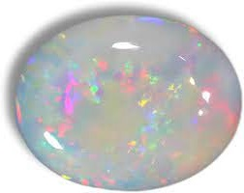

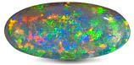

|  |  |
| --- | --- |
| **Chemical Formula:** | **SiO2·nH2O** |
| **Crystal Structure:** | **No Crystal System** |
| **Colour:** | **Red, yellow and orange** |
| **Lustre:** | **Waxy to vitreous** |
| **Transparency:** | **Translucent to Semi-transparent**  E:\Personal Data\images (5).jfif |
| **Fracture** | **Conchoidal** |
| **Cleavage:** | **No cleavage** |
| **Hardness:** | **5.5 to 6.5** |
| **Density:** | **2.21 to 2.20 g/cm³** |
| **Form:** | **Amorphous** |
| **Refractive Index:** | **1.37 to 1.52** |
| **Double Refraction:** | **None** |
| **Fluorescence:** | **Present** |

**OCCURANCES:- Opal is found in various regions around the world, including:**

1. **Australia: Australia is the largest producer of opals, particularly famous for its black opals from Lightning Ridge and white opals from Coober Pedy and Andamooka.**
2. **Ethiopia: Ethiopia is known for its high-quality black opals.**
3. **Mexico: Mexico produces opals, including fire opals known for their fiery orange and red colors.**
4. **Brazil: Brazilian opals, including the famous crystal opals, are well-regarded.**

**VARIETIES:-**

1. **Precious Opal: Precious opal displays a vibrant play of colors and is highly valued.**
2. **Fire Opal: Known for its vivid orange, red, and yellow colors.**
3. **Black Opal: Black opal is characterized by a dark body color with vibrant play of colors.**
4. **Crystal Opal: Transparent to semi-transparent opal with play of colors.**
5. **Boulder Opal: Found in ironstone matrix, it often forms in veins and is known for its unique patterns.**
6. **Common Opal: Also called "potch," it lacks the play of colors seen in precious opal.**

**GEOLOGY:- Opal forms in voids and cavities within sedimentary rocks, such as sandstone, and in volcanic rocks. The play of colors in opal arises from the arrangement of silica spheres within these cavities.**

**METAPHYSICS:- In metaphysical and healing traditions, opal is associated with various qualities, including:**

1. **Creativity and Inspiration: Opal is believed to enhance creativity and inspire new ideas.**
2. **Emotional Balance: It is thought to bring emotional balance and clarity.**
3. **Protection: Opal is sometimes used for protection and enhancing intuition.**

**USES:- Opal's unique play of colours and stunning beauty make it a prized gemstone, highly valued for its aesthetic appeal.**

1. **Jewelry: Opal is highly sought after for use in rings, necklaces, earrings, and other forms of jewelry.**
2. **Collector's Gem: Opal is collected and appreciated by gem enthusiasts and collectors.**
3. **Art and Decor: It is used in art, sculpture, and decorative objects.**
4. **Metaphysical Practices: Opal is used in crystal healing, meditation, and energy work.**

**AVENTURINE**

**INTRODUCTION: - Aventurine is composed primarily of quartz, which is one of the most abundant**[**minerals**](https://geologyscience.com/minerals/)**on Earth. Its distinctive shimmering effect is caused by tiny inclusions of other minerals, such as**[**mica**](https://geologyscience.com/minerals/mica-group-minerals/)**,**[**hematite**](https://geologyscience.com/minerals/hematite/)**, or fuchsite, which reflect light and create a glittering appearance. The most common color of aventurine is green, but it also occurs in shades of blue, red, peach, yellow, and white.**

**Aventurine is a type of quartz with inclusions of various minerals. It is primarily composed of silicon dioxide (SiO2), the same chemical composition as other quartz minerals. Aventurine may exhibit chatoyancy, also known as the "cat's eye" effect, caused by the reflection of light from fibrous or needle-like inclusions within the stone.**

**IDENTIFICATION PROPERTIES:-**

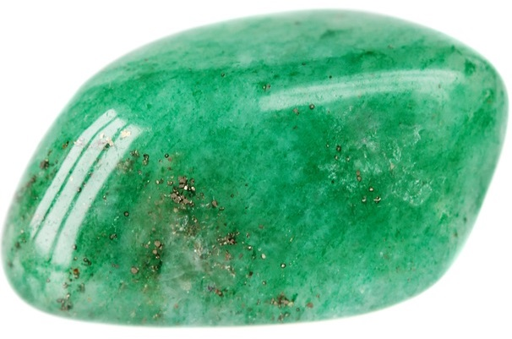

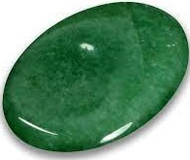

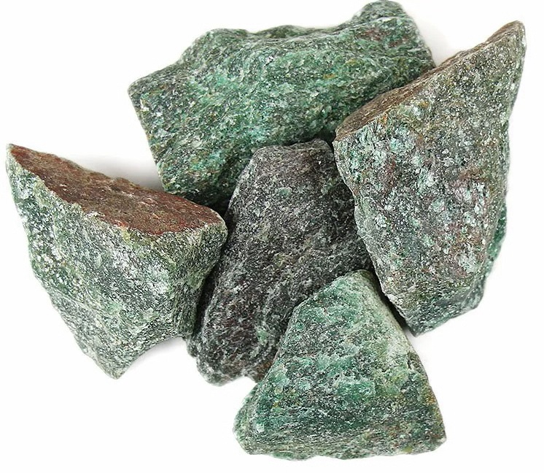

|  |  |
| --- | --- |
| **Chemical Formula:** | **Silicon dioxide (SiO2),** |
| **Crystal Structure:** |  |
| **Colour:** | **Green** |
| **Lustre:** | **Vitreous to metallic** |
| **Transparency:** | **Translucent to Opaque** |
| **Fracture** | **Conchoidal** |
| **Cleavage:** | **No cleavage** |
| **Hardness:** | **6.5 to 7.0** |
| **Density:** | **2.64 to 2.69 g/cm³** |
| **Refractive Index:** |  |
| **Double Refraction or Birefringence:** |  |
| **Fluorescence:** |  |

**OCCURANCES:- Aventurine can be found in various regions around the world, including:**

1. **India: Known for green aventurine.**
2. **Brazil: Aventurine, including blue and green varieties, is found in Brazilian mines.**
3. **Russia: Aventurine is found in Siberia and the Urals.**
4. **South Africa: Green aventurine is found in South African mines.**

**VARIETIES:-**

1. **Green Aventurine: The most common and well-known variety, known for its green color and glittering appearance.**
2. **Blue Aventurine: Contains blue or blue-green inclusions, often derived from minerals like dumortierite.**
3. **Red Aventurine: Features red or reddish-brown hues, sometimes due to hematite inclusions.**
4. **Brown Aventurine: Has brownish tones and may contain hematite or goethite.**
5. **Yellow Aventurine: Exhibits yellowish colors, sometimes with mica inclusions.**

**GEOLOGY:- Aventurine is a type of quartz with inclusions of various minerals. It often forms in igneous, metamorphic, or sedimentary rocks. The sparkling appearance is usually caused by inclusions of mica, hematite, or other minerals.**

**METAPHYSICS:- In metaphysical and healing traditions, aventurine is associated with various qualities, including:**

1. **Prosperity: Aventurine is believed to attract prosperity and abundance.**
2. **Emotional Healing: It is thought to promote emotional well-being, calmness, and balance.**
3. **Heart Chakra: Aventurine is associated with the heart chakra and is used for matters of the heart and love.**

**USES:-**

1. **Jewelry: Aventurine is widely used in jewelry, especially for beads, cabochons, and pendants.**
2. **Carvings and Figurines: It is often carved into figurines, ornaments, and small sculptures.**
3. **Holistic Healing: Aventurine is used in crystal healing practices, energy work, and meditation.**
4. **Decorative Objects: It is used for decorative purposes, including vases and tabletops.**